PHASE-3:

**A CRM Application to Manage the Services offered by an Institution**

>>

**Phase 3: Data Modeling & Relationships**

**Step 1: Goal of Phase 3**

* Build a data model for the CRM to manage institutional services.
* Define standard & custom objects, fields, relationships, and layouts.
* Expected Outcome: Ready for automation, reporting, and UI configuration in Phase 4.

**Step 2: Standard & Custom Objects**

**>>**

**Create Course Object**

1. Go to your **object manager** and and click on **create object from spreadsheet**.
2. Click on the **link** to get the spreadsheet, **Course**.
3. After downloading, **upload the file**, **map the fields** and upload to create an object.

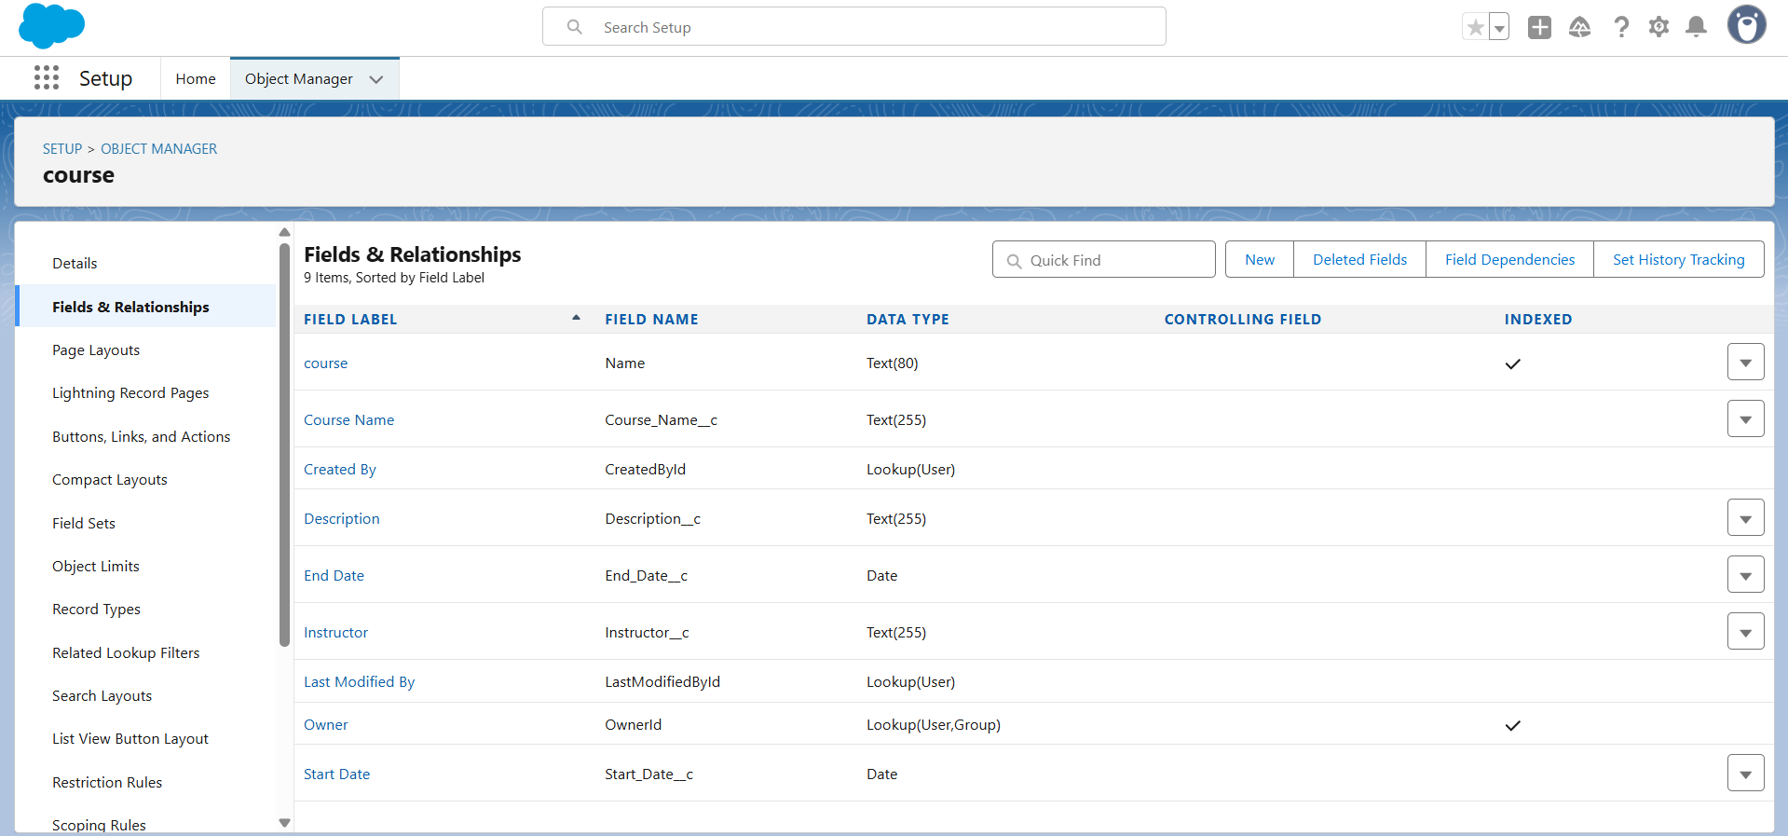

**Custom Objects:**

**Create Remaining Objects**

1. Follow the steps which we have followed for course object creation.
2. Use the following sheets for remaining objects.

a. Consultant

b. Student

c. Appointment

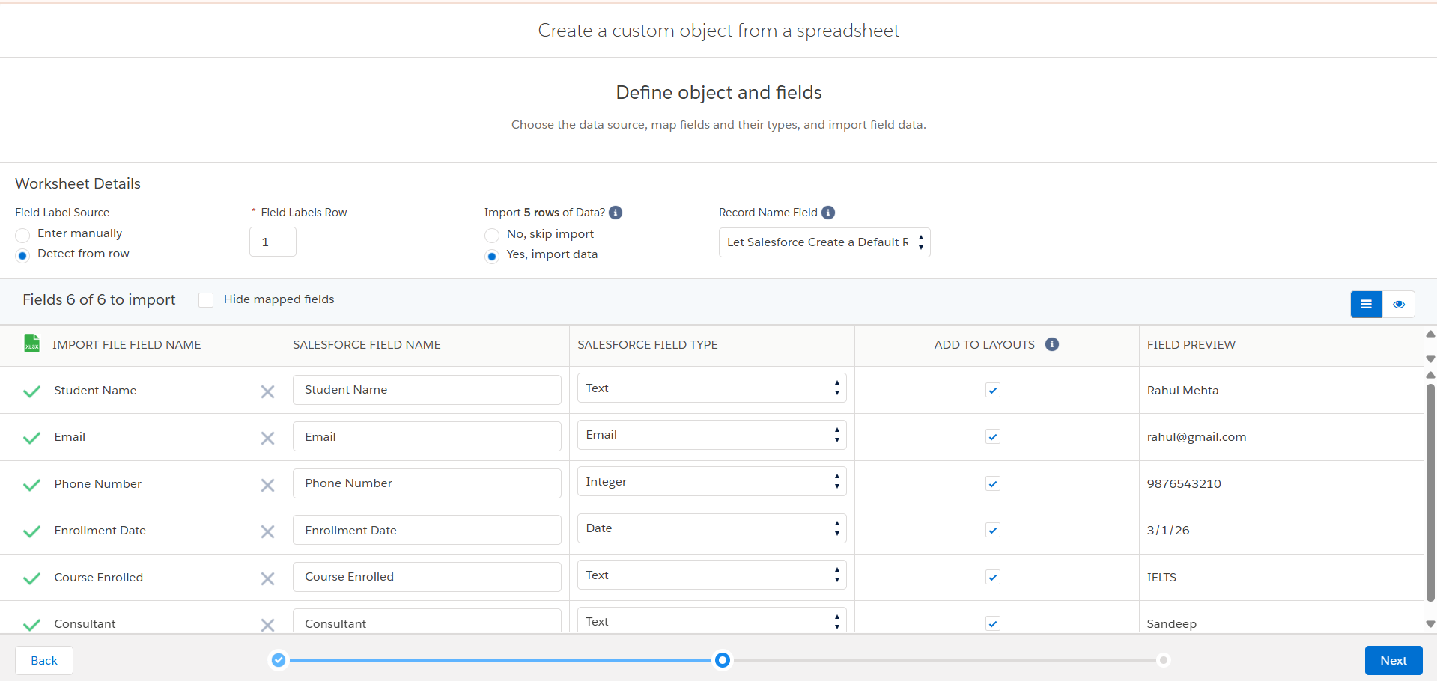

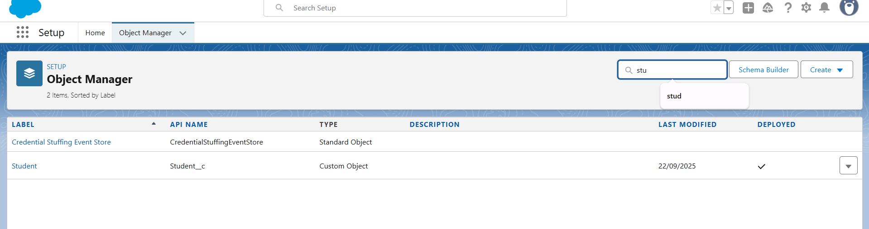

Consultant:

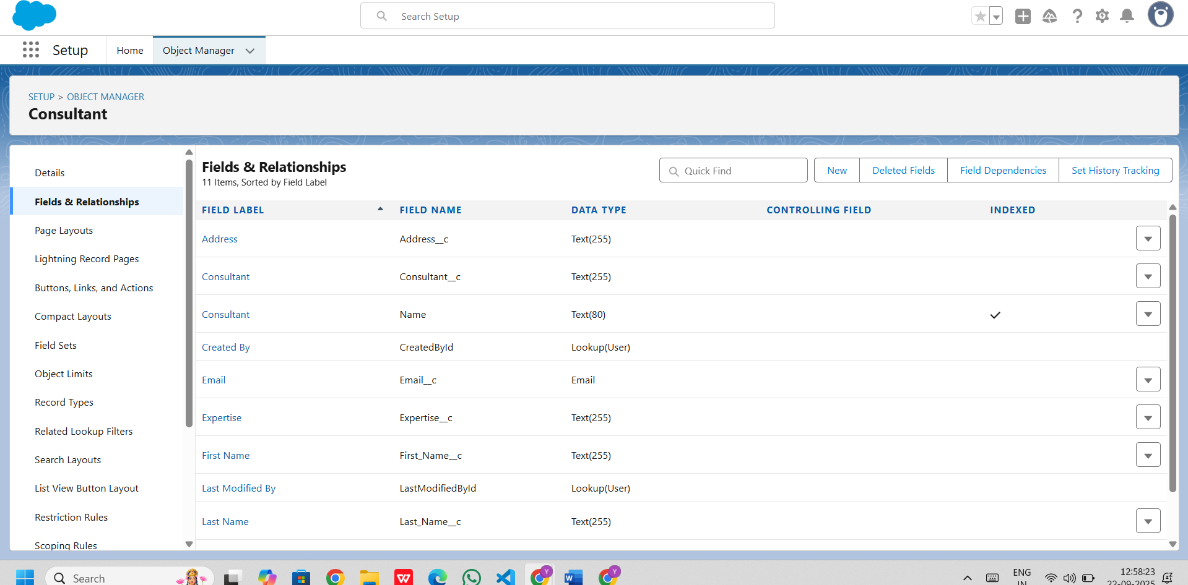

Appointment

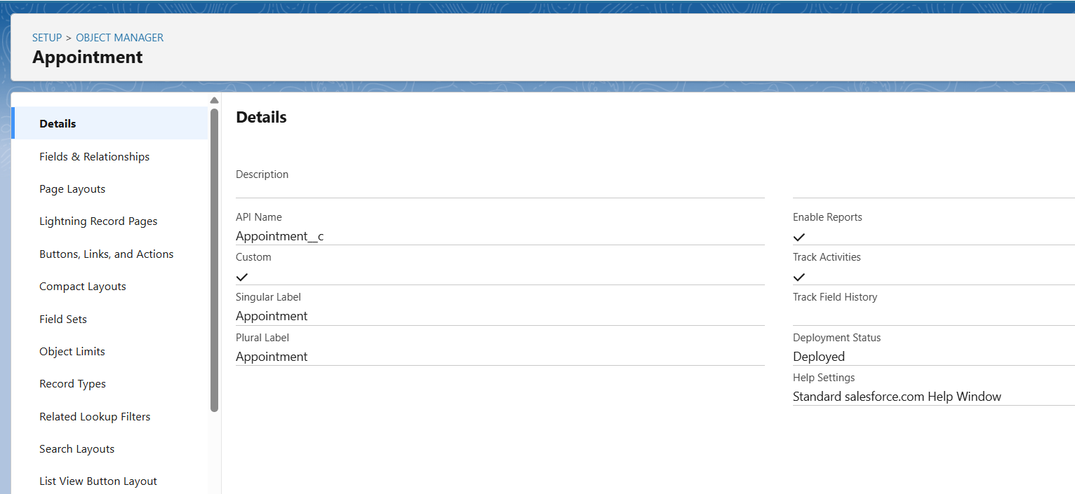

**Steps to create custom object:**

* **Setup → Object Manager → Create → Custom Object from Spreadsheet**
* **Upload Spreadsheet:** Browse and select your prepared file.
* **Map Fields:** Verify Salesforce mapped columns correctly.
* **Verify & Edit:**
* Go to **Fields & Relationships**.
* Check all fields, adjust data types or picklists if needed.
* **Configure Layouts & Relationships:**
* **Page Layouts:** Arrange fields into sections.
* **Lightning Record Pages:** Configure UI.
* **Relationships:** Add Lookup or Master-Detail links (e.g., Student → Course).

**Create Relationship Among the Objects**

1. Create lookup between appointment and student, appointment and consultant.
2. Create an object to store the information student and course details with the name Registration.
3. Also create a lookup between student and case to store the student queries for immigration or visa application.
4. The data model should be similar to the below Data Model with fields & relationships:

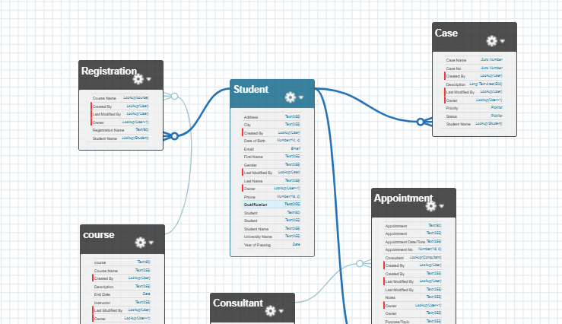

**Configure The Case Object**

1. Go to object manager, edit case object.
2. Select the **"Type"** field and add the values in it.
   * Immigration
   * Visa Application
3. Now Select the **"Status"** field and add the values in it.
   * Open
   * In-progress

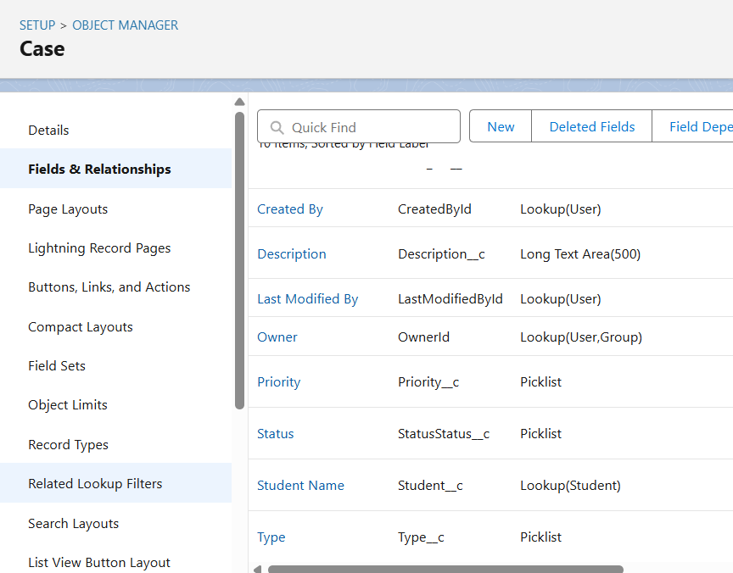

**Create A Lightning App**

1. Go to **Setup**, search for the **App Manager** in quick find.
2. Click on **New Lightning App**.
3. Give app name as **"EduConsultPro"**, click Next, Next, Next.
4. Add **Home, Students, Courses, Consultants, Appointments, Registrations, and Cases** from the Available Items to Selected Items.
5. Add **"System Administrator"** profile from Available Profiles to Selected Profiles, click **Save & Finish**.

**Steps to Create Record Types for Cases**

**Step 1: Go to Object Manager**

1. Go to **Setup → Object Manager → Case**.

**Step 2: Create a New Record Type**

1. Click **Record Types → New Record Type**.
2. Enter:
   * **Record Type Label:** Immigration Case
   * **Record Type Name (API Name):** Immigration_Case
   * **Description:** For tracking immigration-related requests
   * **Enable for Profiles:** Select **System Administrator** (you can select other profiles later)
3. Click **Next**.

**Step 3: Repeat for Visa Application**

1. Click **New Record Type** again.
2. Enter:
   * **Label:** Visa Application
   * **API Name:** Visa_Application
   * **Description:** For tracking student visa applications
3. Assign a page layout with fields like **Case Details, Student Lookup, Status, Visa Type (if any)**
4. Click **Save**.

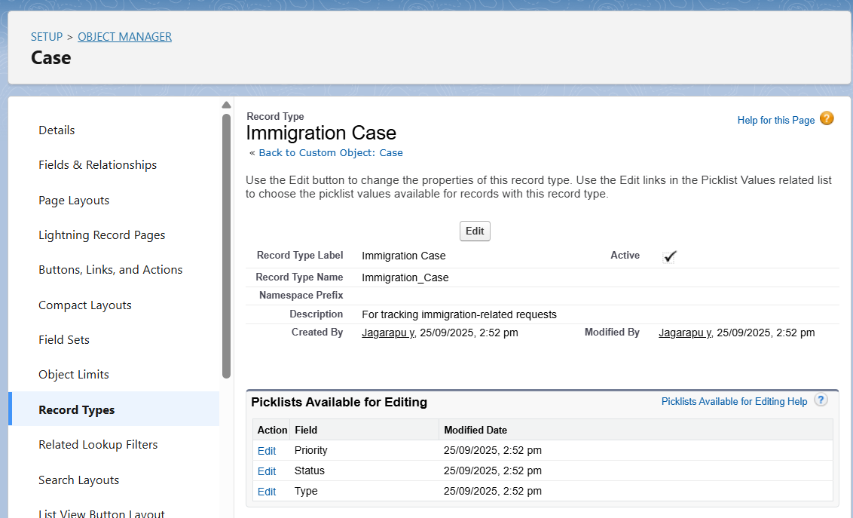

**Step 5: Page Layouts**

**Steps to Create/Edit Page Layouts**

**Step 1: Go to Object Manager**

1. **Setup → Object Manager → Select Object** (e.g., Student, Course, Appointment, Case).

**Step 2: Open Page Layouts**

1. In the object, click **Page Layouts** in the sidebar.
2. Click **New** or select an existing layout to edit.

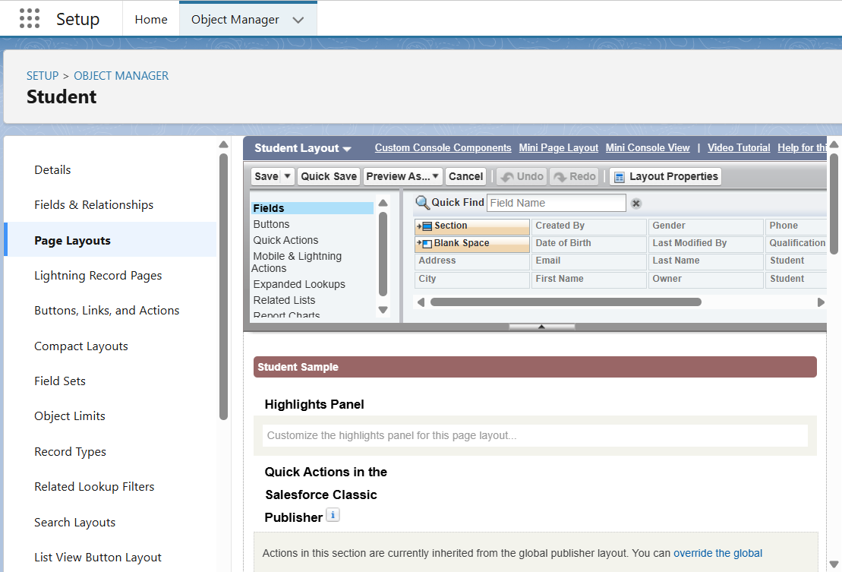

**Step 6: Compact Layouts**

**Steps to Create a Compact Layout:**

1. Go to **Setup → Object Manager → Student (or any object) → Compact Layouts**
2. Click **New**
3. Enter **Layout Name**, e.g., Student_Compact_Layout
4. Drag **key fields** to the layout:
   1. Example for Student: Name, Email, Phone, Qualification
5. Click **Save**
6. Set as **Primary** to make it the default compact layout for the object
7. 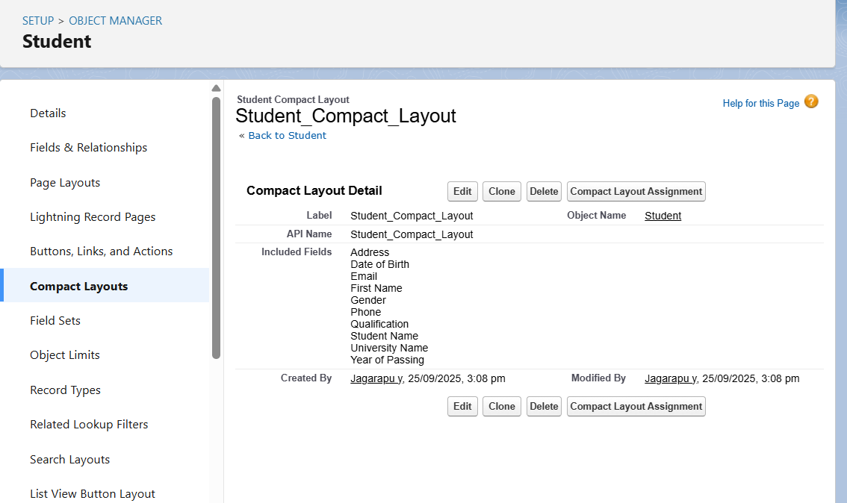

**Step 7: Schema Builder**

* Visual representation of objects & relationships.
* Useful to validate relationships and dependencies before development.

**Steps:**

1. Setup → Schema Builder
2. Drag standard/custom objects → Connect relationships
3. Save changes

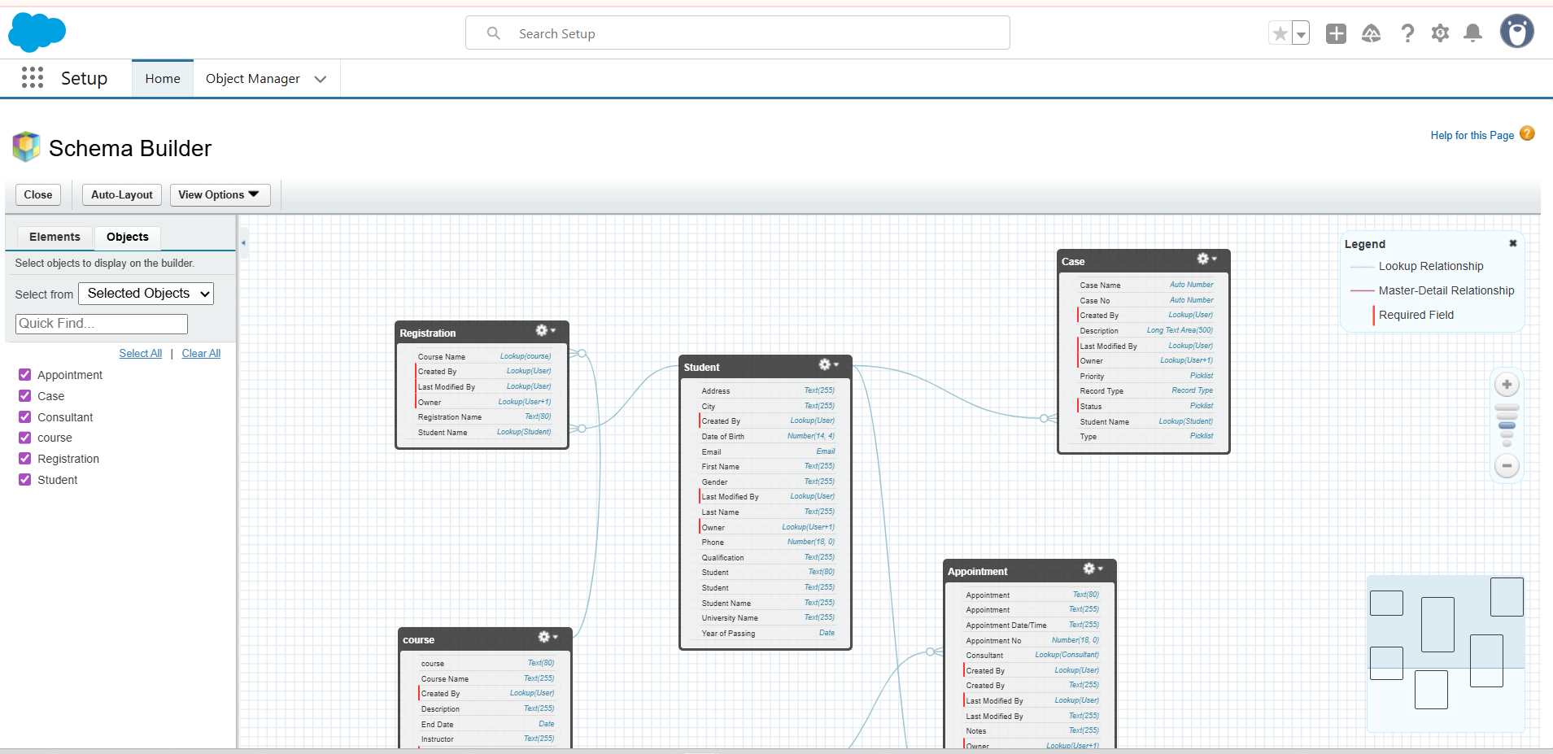

**Step 8: Relationships**

**. Lookup Relationship**

1. **Click on “Relationship” → Lookup Relationship in the left panel.**
2. **Drag from the child object to the parent object.**
   * **Example: Appointment → Student**
3. **Define the relationship name and field properties.**
4. **Save.**

**B. Master-Detail Relationship**

1. **Click on “Relationship” → Master-Detail Relationship.**
2. **Drag from child object to parent object.**
   * **Example: Registration → Student and Registration → Course**
3. **Define the relationship (e.g., roll-up summary fields if needed).**
4. **Save.**

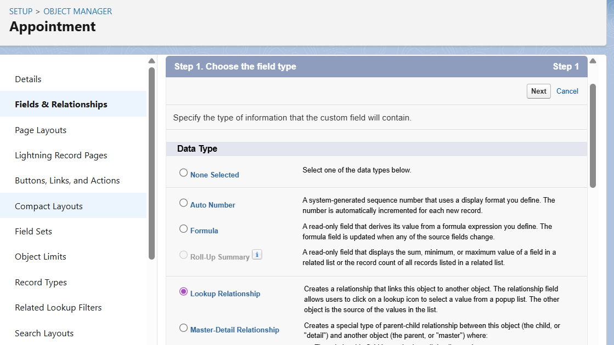

**Step 9: External Objects**

* Represent data stored outside Salesforce.
* Example: ERP student records, library database.
* Access via Salesforce Connect (OData, REST/SOAP)

**Steps:**

1. Setup → External Data Sources → New
2. Configure connection → Validate → Sync objects
3. Map external objects and fields

